

**North South University**

# Department of Electrical & Computer Engineering

**LAB REPORT**

Course Code: EEE141L

Course Title: Electrical Circuits I Lab

Course Instructor: Dr. Mohammad Abdul Matin (Mtn)

Experiment Number: 2

Experiment Name:

|  |
| --- |
| KCL, Current Divider Rule with Parallel and Ladder Circuit |

Experiment Date: 11/3/2021

Date of Submission: 17/3/2021

Section: 3

Submitted To: Tabia Hossain

|  |  |
| --- | --- |
| Submitted By | Score |
| Student Name and ID:  1. Md. Rifat Ahmed - 1931725042 |  |

**Objectives:**

• Validate the current divider rules.

• Verify Kirchhoff’s current law.

• Verify KCL and KVL in ladder circuit.

**List of Equipment:**

• OrCAD Software

• PSpice Software

• Resistors (1k, 3.3kΩ, 4.7kΩ, 5.6kΩ, 10k)

• Connecting Wires

**Theory:**

**Kirchhoff’s Current Law (KCL):**

Kirchhoff’s current law states that the algebraic sum of all the currents entering and exiting a node or a closed loop circuit is zero.

Alternatively, it could also be said that the total amount of currents entering a node is equal to the currents exiting from that node.

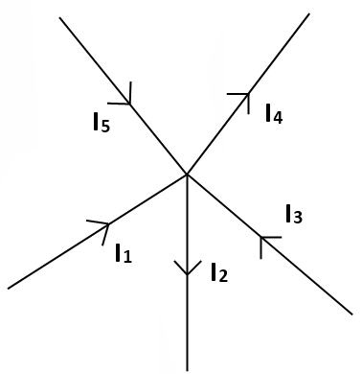

Figure – 1

For example, if we apply KCL to Figure-1 the algebraic sum of all the currents entering and exiting should be equal to zero. And if we consider the currents exiting from the node as negative, we get,

I1 + I3 + I5 - I2 - I4 = 0

Or, if we consider the alternative form of KCL the sum of the currents entering the node (I1, I3, I5) there should be equal to the currents exiting (I2, I4) from it. So,

I1 + I3 + I5 = I2 + I4

**Current Division Rule:**

The current division rule states that the current entering the node of a parallel circuit is divided into the resistors of the branches in inverse proportion to their resistances.

So, when the current is flowing in a circuit if it encounters parallel branches it’ll get divided into the resistors in those branches of the circuit.

For a circuit with two resistors in parallel the current flowing through each resistor will be, “the resistance in the opposite branch divided by the total resistance and multiplied by the total current” and the formula to calculate the currents divided into the resistor will be as following,

I1 = x IS

I2 = x IS

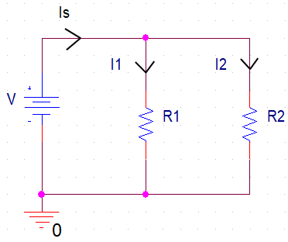

Figure – 2

For a circuit with three resistors in parallel the formula to calculate the currents divided into the resistors is a bit different from the formulas used for the circuit with two parallel resistors. They’ll be,

Req =

I1 = x IS

I2 = x I S

I3 = x IS

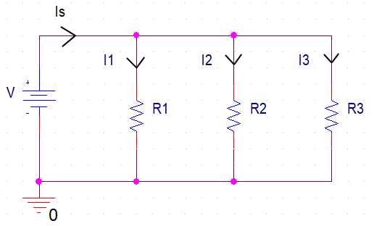

Figure – 3

So, the technique is to take the total resistance in the parallel circuit and divide it by the resistance of the resistor that we’re trying to find the current flow of and multiply it with the total current.

**Ladder Circuit:**

A ladder circuit is the kind of circuit that we commonly use which is a mixture of both series and parallel circuits unlike the previous circuits we’ve seen where it’s either only series or only parallel connections.

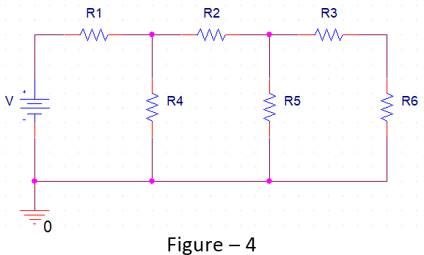

**Circuit Diagram:**

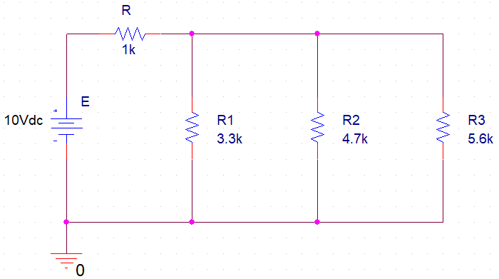

**Circuit – 1**

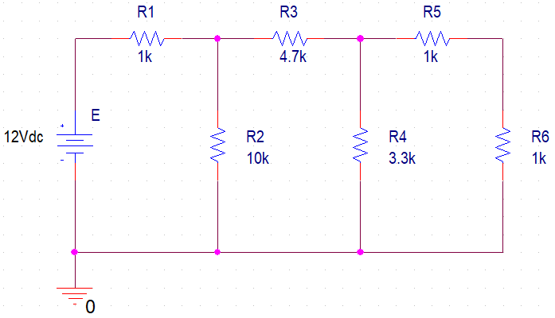**Circuit – 2**

**Data, Readings and Results:**

**Table 2:**

|  |  |  |  |  |  |  |  |
| --- | --- | --- | --- | --- | --- | --- | --- |
| **Experimental readings** | | | | **Theoretical values** | | | |
| **IS (mA)** | **IR1 (mA)** | **IR2 (mA)** | **IR3 (mA)** | **IS (mA)** | **IR1 (mA)** | **IR2 (mA)** | **IR3 (**mA**)** |
| 4.098 | 1.789 | 1.256 | 1.054 | 4.098 | 1.788 | 1.256 | 1.054 |
| **% Error** | | | | | | | |
| **IS** | | **IR1** | | **IR2** | | **IR3** | |
| 0% | | 0.06% | | 0% | | 0% | |

**Percentage Error Calculation:**

% Error for IS = × 100%

= $|\frac{4.098 – 4.098}{4.098}|$ × 100% = 0%

% Error for IR1 = × 100% = 0.06%

% Error for IR2 = × 100% = 0%

% Error for IR3 = × 100% = 0%

**Table 3:**

|  |  |  |
| --- | --- | --- |
| **IS** | 4.098mA | **Is Total Current equal to the sum of individual current?** |
| **Sum of individual Current (IR1 + IR2 + IR3)** | 4.099mA | Almost Equal |

**Table 5:**

|  |  |  |
| --- | --- | --- |
| **Component** | **Voltage** | **Current** |
| **E** | 12V | 2.538mA |
| **R1** | 2.538V | 2.538mA |
| **R2** | 9.462V | 0.946mA |
| **R3** | 7.480V | 1.592mA |
| **R4** | 1.982V | 0.601mA |
| **R5** | 0.991V | 0.991mA |
| **R6** | 0.991V | 0.991mA |

**Questions and Answers:**

**Answer of Question 1:**

The current divider rule states that the current entering the node of a parallel circuit is divided into the branches in reverse proportion of the resistances of those branches.

**Answer of Question 2:**

Kirchhoff’s current law states that the algebraic sum of all the currents entering and exiting a node is equal to zero.

**Answer of Question 3:**

Verifying KVL within each independent closed loop of circuit-2:

From Table 3 we get the experimental values,

E = 12V

VR1 = 2.538V

VR2 = 9.462V

VR3 = 7.480V

VR4 = 1.982V

VR5 = 0.991V

VR6 = 0.991V

There are total 3 independent closed loops in our circuit-2.

Now, Applying KVL at Loop 1,

-E + VR1 + VR2 = 0

=> E = VR1 + VR2

=> 12V = 2.538V + 9.462V

=> 12V ≈ 12V

Applying KVL at Loop 2,

-VR2 + VR3 + VR4 = 0

=> VR2 = VR3 + VR4

=> 9.462V = 7.480V + 1.982V

=> 9.462V ≈ 9.462V

Applying KVL at Loop 3,

-VR4 + VR5 + VR6 = 0

=> VR4 = VR5 + VR6

=> 1.982V = 0.991V + 0.991V

=> 1.982V ≈ 1.982V

Here, we can see that for all three loops the total voltage around the loop is equal to the sum of all the voltage drops within the same loop. Which means that all three loops follow KVL.

**؞** KVL is verified for all the independent closed loops of the circuit.

**Answer of Question 4:**

Verifying Kirchhoff’s current law at nodes a and b of circuit-2:

Applying KCL at node ‘a’ we get,

IR1 = IR2 + IR3

With the experimental data from Table 5 we get,

2.538mA = 0.946mA + 1.592mA

= 2.538 mA

Here, we can see that the amount of current going into node a is equal to the total current going out of the node.

**؞** KCL verified at node ‘a’.

Now, again applying KCL at node ‘b’ we get,

IR3 = IR4 + IR5

With the experimental data from Table 5 we get,

1.592mA = 0.601mA + 0.991mA

= 1.592mA

Here, we can see that the amount of current going into node b is equal to the total current going out of the node.

**؞** KCL verified at node ‘b’.

**Answer of Question 5:**

Calculating the theoretical values for Table 2:

Given,

E = 10V

R = 1kΩ

R1 = 3.3kΩ

R2 = 4.7kΩ

R3 = 5.6kΩ

**؞** Total Resistance in Parallel branches, Req =

= = 1.44 kΩ

**؞** Total Resistance, RT = R + Req

= 1kΩ + 1.44kΩ

= 2.44 kΩ

**؞** Total Current, IT = E/RT

= 10V / (2.44 × 103 ­Ω)

= 4.098 × 10-3 A

= 4.098 mA

Now, Using Current Divider Rule,

**؞** IR1 = × IT

= × 4.098mA = 1.788 mA

**؞** IR2 = × IT

= × 4.098mA = 1.256 mA

**؞** IR3 = × IT

= × 4.098mA = 1.054 mA

From Table 2 we can see that the experimental and theoretical values of IS, IR3, IR4 are exactly the same and the value of IR2 is almost same. And from KCL we know that the total current entering and exiting should be zero. The amount of current entering in the Circuit is 4.098mA and the sum of the total amount of current going out is also 4.098mA so the algebraic sum of total current entering and exiting is zero.

**؞** Our circuit follows KCL.

**Answer of Question 7:**

Given,

E = 12 V

R1 = 1 kΩ

R2 = 10 kΩ

R3 = 4.7 kΩ

R4 = 3.3 kΩ

R5 = 1 kΩ

R6 = 1 kΩ

In the circuit, R5 and R6 are in series. So,

RS1 = R5+R6 = 1+1 = 2kΩ

RS1 is in parallel with R4,

RP1 = = = 1.25 kΩ

Then R3 is in series with RP1,

RS2 = 4.7+1.25 = 5.95 kΩ

Then R2 is in parallel with RS2,

RP2 = = = 3.73 kΩ

Finally, R1 is in series with RP2. So, the total resistance across the circuit,

RT = R1+RP2 = 1+3.73 = 4.73 kΩ

**؞** Total Current across the circuit,

IS = E/RT = 12V / (4.73 x 103 Ω) = 2.54 x 10-3 A

= 2.54 mA

Now, IR1 = IS = 2.54 mA

VR1 = IR1 × R1 = 2.54 × 1 = 2.54V

VR2 = E – VR1 = 12 – 2.54 = 9.46V

IR2 = VR2 / R2 = 9.46/10 = 0.946mA

IR3 = IR1 – IR2 = 2.54 – 0.946 = 1.594mA

VR3 = IR3 ×R3 = 1.594 × 4.7 = 7.492V

VR4 = VR2 – VR3 = 9.46 – 7.492 = 1.968V

IR4 = VR4 / R4 = 1.968/3.3 = 0.596mA

IR5 = IR3 – IR4 = 1.594 – 0.596 = 0.998mA

VR5 = IR5 × R5 = 0.998 × 1 = 0.998V

IR6 = IR5 = 0.998mA

VR6 = IR6 × R6 = 0.998 × 1 = 0.998V

**Discussion:**

From this experiment we’ve learned the use of Kirchhoff’s current law and the alternative form of KCL, then we learned the current division rule for circuits with two parallel resistors and for circuits with three parallel resistors and if there was more resistors, we could follow the same technique as we did for the three parallel resistor circuit and then we learned what’s a ladder circuit. We’ve also learned to verify the KCL. Now coming to the result analysis, our experimental values and the theoretical values didn’t vary much and were almost the same and because of that the error in our results were almost zero. Then we verified KVL for each independent closed loop and then by using KCL on node a and b of the circuit we saw that it follow KCL at those nodes too. After that in the Data, Reading and Results part we got almost a similar data readings and theoretical values. Due to that we got almost similar results for both experimental and theoretical values. So, the practical results were very much similar to the theoretical results as there wasn’t any noticeable deviation there. Now the only problem during this experiment was that we had to rely on computer generated data using the OrCAD software to use as the experimental values as we can’t do the experiment in real with actual circuits and resistors. So, the experimental values we had might not be as realistic as we had gotten if it was done in real life so doing the experiment online without using any actual hardware is a big drawback for our experiment.